CAMERA VIDEO SIGNAL CABLE

- PARTS:

QUANTITY: PART #: NOMENCLATURE: LENGTH:

1 PER MACHINE 19275- CABLE, CO-AXIAL 180 INCHES

2 PER MACHINE 17648- CONNECTOR, BNC, 75Ω, 27 AWG N/A

- ASSEMBLY:

- SLIDE THE CONNECTOR CRIMP TUBES ONTO THE CO-AXIAL CABLE.

- STRIP ¾” OF THE OUTER INSULATION FROM THE CABLE ENDS.

- TRIM THE EXCESS SHIELDING FROM THE CABLE.

- STRIP 5/16” OF THE INNER INSULATION FROM THE CABLE ENDS.

- PLACE THE BARE ENDS OF THE CABLE IN A VISE.

- COAT THE BARE CONDUCTORS WIH FLUX, AND TIN THEM.

- INSERT THE BARE CONDUCTOR,WHILE HEATING IT, INTO THE CONNECTOR PIN.

- REMOVE THE SOLDERING IRON FROM THE CONDUCTOR/PIN.

NOTE 1
TEST THE CONNECTION BY PULLING ON IT. IF THE PIN PULLS OFF OF THE CONDUCTOR, REDO STEPS 2F THROUGH 2H UNTIL IT PASSES THE PULL TEST.

- INSERT THE PIN/CABLE ASSEMBLY INTO THE BNC COVER.

- THE ASSEMBLY SHOULD CONNECT ACCORDING TO DIAGRAM 1.
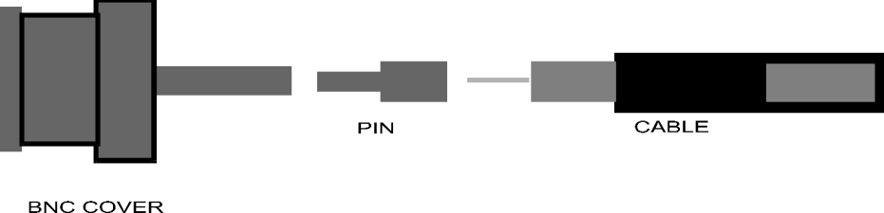

DIAGRAM 1

